**Section 1–5A: Solving Basic Inequalities**

Words like “at most” and “at least” suggest a relationship in which two quantities may not be equal. You can represent such a relationship with a mathematical inequality.

Inequalities problem can be tricky, if you don’t pay attention to the words of the problem. It is always a great idea to check your solutions after you had completed an inequality problem, but first, you need to know how to graph and write inequalities.

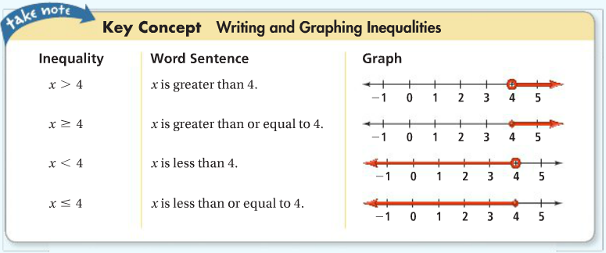

In the graphs above, the point at 4 is a boundary point because it separates the graph of the inequality from the rest of the number line. An open dot at 4 means that 4 ***is not*** a solution, and a closed dot at 4 means that 4 ***is*** a solution.

**Example 1:**

What inequality represents the sentence, “The quotient of a number and 3 is no more than 15”?

**Key Words:** A Number = A Variable $(x)$

Quotient = Division $(÷)$

No More Than = Less Than or Equal To $(≤)$

Solution: $x÷3≤15$ or $\frac{x}{3}≤15$

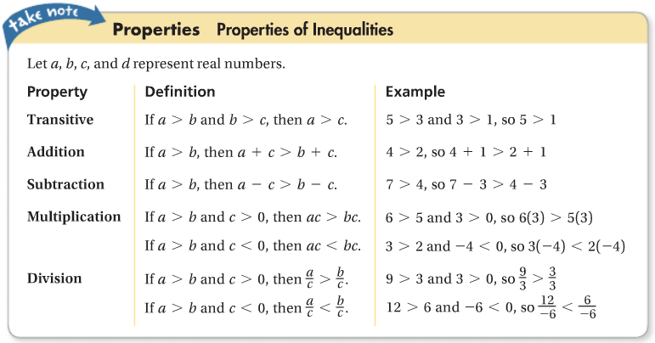

The solutions of an inequality are the numbers that make it true. The properties you use for solving inequalities are similar to the properties you use for solving equations. However, when you multiply or divide each side of an inequality by a negative number, you must reverse the inequality symbol.

**Why It Works?**

The steps below show that if $a>b$, then $–a<-b$. Therefore, you need to reverse the inequality symbol when multiplying each side of the inequality $a>b$ by $-1$.

$a>b$ Subtract *b* from each side.

$a-b>0$ $a-b=-b+a=-b-(-a)$.

$-b-\left(-a\right)>0$ Add $–a$ to each side.

$-b>-a$ Rewrite the inequality with $–a$ on the left side.

$$-a<-b$$

**Example 2:**

What is the solution of $-3\left(2x-5\right)+1≥4$? Graph the solution.

$-3\left(2x-5\right)+1≥4$ Distributive property.

$-6x+15+1≥4$ Simplify.

$-6x+16≥4$ Subtraction property of inequality.

$-6x≥-12$ Divide each side by $-6$ and reverse the inequality symbol.



$x≤2$

**Example 3:**

A digital music service offers two subscription plans. The first has a $9 membership fee and charges $1 per download. The second has a $25 membership fee and charges $0.50 per download. How many songs must you download for the second plan to cost less than the first plan?

**Define:** Let *n* = the number of songs downloaded

**Write:** First Plan: $9+1(n)$

Second Plan: $25+0.50(n)$

**Solve:** Second Plan $<$ First Plan

$25+0.5n<9+n$

$16<0.5n$

$32<n$ or $n>32$

**Result:** You must download **more than 32 songs** in order for the second plan to cost less than the first plan.

**Example 4:**

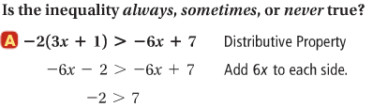

The last ineqaulity $-2>7$ is false, so $-2\left(3x+1\right)>-6x+7$ is always false. It has no solution, so it is never true.

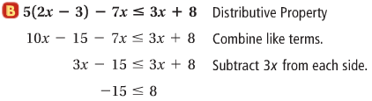

The last inequality $-15≤8$ is true, so $5\left(2x-3\right)-7x≤3x+8$ is always true. All real numbers are solutions.

**What does it mean for an inequality to be sometimes true?**

An inequality is sometimes true if it is true for some, but not all, values of the variable.